Large scale or small scale? | Uses | Tips for safe use | Advantages  Canteen Tour | Disadvantages
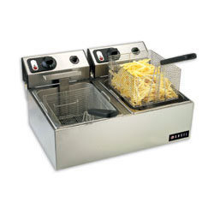  Deep Fat Fryer | - Chips  - Battered Fish  - Chicken goujons /nuggets  - Sausages  - Doughnuts  - Churros | - Always clean up spillages immediately  - Provide safety training for staff  - Always use basket provided for lowering food into hot fat  - Drain food before serving to remove excess oil  - Never leave unattended  - Place lid on while food is frying  - Make sure oil has reached required temperature | - Uses temperature controls  - Most use timers for different foods  - Produces consistent results  - Can fry large quantities of ingredients | Expensive to replace  Not very healthy method of cooking  Oil needs changing regularly to maintain quality of food  Can easily cause a fire in the kitchen  Needs time to achieve required temperature
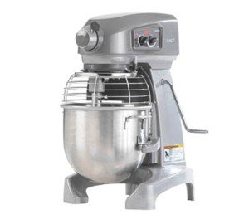  Hobart Food Mixer | - Scone mix  - Bread Dough  - Pastry  - Cakes | - Always allow blades to stop turning before removing guard  - Ensure safety guard is attached before turning on  - Always refer to manual  - When cleaning do not let electrical parts come into contact with water or cleaning materials  - Select the correct bowl for type of mixture and then select correct beater or whip  - Do not put hand or spoons into bowl while the mixer is in operation | - Time saving  - Can produce food in bulk quantities  - Versatile  - Labour saving  - Reduces labour costs  - Produces consistent results | - Requires regular maintenance  - Can be costly to run  - Not very energy efficient
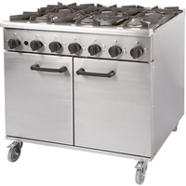  Oven | - Boiling  - Steaming  - Sautéing  - Roasting  - Braising  - Baking  - Frying  - Stir-frying | - Pan handles facing inwards  - Oven gloves should be used  - Use appropriate size hob for the pan  - Never leave unattended when in use  - Clean up any spillages quickly but only once it is cool | - Can be used for many different functions at same time such as frying and baking  - Can cook food in large quantities and batches  - Can be gas, electric or induction which are more energy efficient  - Often have timers for cooking | - Takes up a lot of space  - Expensive to replace  - Requires regular maintenance  - Needs regular cleaning
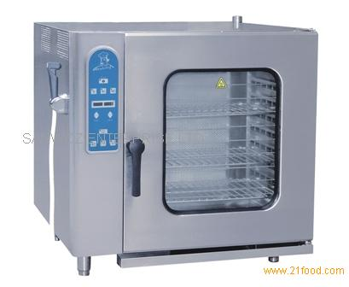  Steamer | - Vegetables  - Chicken  - Fish  - Steamed puddings | - Follow instructions in manual  - Shut off steam if pressure rises above safety level  - Guard against possible steam burns when opening door  - Clean up spilled foods once equipment has cooled down | - Healthy method of cooking  - Labour and time saving  - Can steam food in large batches | - Steam can cause painful and dangerous scalds  - Requires a lot of room  - Expensive to buy and install
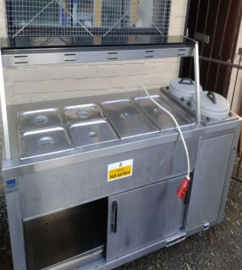  Bain Marie/Hot Cupboard | - Keeping food hot during service using a water bath (bain-marie) | - Hot holding of foods should be no longer than 2 hours to prevent food poisoning  - Warning signs to be used to notify customers of hot surfaces | - Maintains consistent temperature of food  - Can be used to keep large quantities of food warm  - Can be used to heat plates before service | - Requires a lot of room.  - Uses a lot of energy  - Time consuming to clean and maintain.
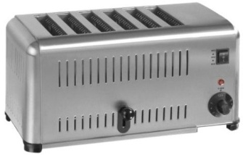  Toaster | Defrosting and toasting the following foods:  - Bread  - Bagels  - Pita Bread  - Croissants  - Naan breads | - Never stick anything into slots to remove items of food  - Refer to manual instructions for guidance  - Always use the eject button for removing food  - Do not let electrical parts come into contact with water  - Clean crumb tray regularly once cold | - Larger than conventional toasters  - Has setting for different foods to ensure consistent results  - Fairly cheap to buy  - Can cook several pieces of food at once  - Particularly useful for breakfast and lunch times | - Elements need replacing regularly  - Regular maintenance required
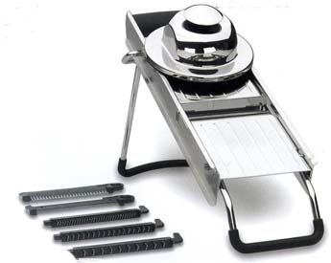  Mandolin Slicer | - Slicing vegetables and cheese  - Grating  - Shredding  - Juicing | - Never use slicer when blade guard is off  - Never catch sliced food with hand  - Do not put in sink where it cannot be seen  - Protective glove can be worn | - Can slice ingredients quickly  - Slices are uniform thickness  - Often comes with many attachments  - Great for presentation of food and garnishes  - Requires less skill than using a knife | - Blades need sharpening regularly  - Difficult to use  - Hard to clean  - Can be very dangerous
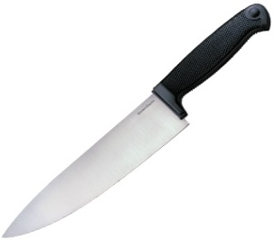  Chefs Knife | - Chopping  - Slicing  - Dicing Cutting  - Vegetables  - Bakery goods  - Meat/fish | Handles should be free from grease  Knives should not be placed in sink where they cannot be seen  Use appropriate size for the food  Always use a sharp knife  Chefs to be trained adequately. | - Invaluable for all chefs used in all kitchen sections | Needs sharpening regularly  Requires technical skill
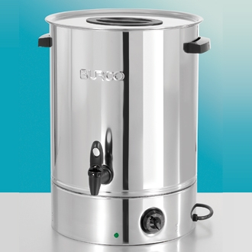  Burco Boiler | - Hot drinks | - Use oven gloves when removing lid to prevent condensation scalds  - Position on flat, stable surface  - Ensure water level is always between min and max level  - Switch off at wall when not in use | - Keeps water at consistent temperature  - Holds large capacity of water  - Has variable temperature guage | - Costly to run.  - Can often leak  - Takes time to heat up  - Outside can get very hot

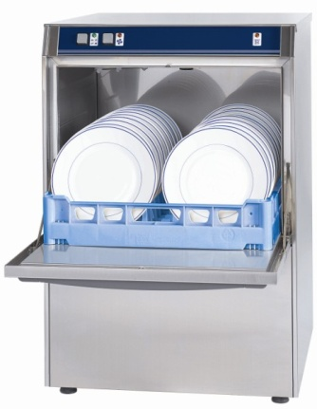 Dishwasher | Cleaning plates, cutlery, glasses, cooking utensils, saucepans, casserole dishes | - Always refer to manual instructions  - Equipment can get very hot so allow to cool before emptying | - Saves time and energy.  - Crockery is sterilised from washing at high temperature  - Ensures sparkling  - Tableware thoroughly cleaned  - Prevents backlog of dishes  - Labour saving | Expensive to run  Requires regular maintenance
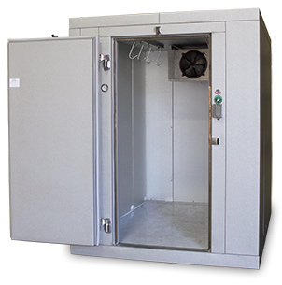  Walk in fridge | - Keeping foods cold such as:  - Dairy  - Cooked/Raw meat  - Cooked food once cooled | - Ensure staff are trained on how to store food within fridge e.g. Raw meat at bottom where juice can’t drip  - Food to be cooled within 2 hours before placing in fridge  - Keep foods covered | - Has digital temperature display.  - Maintains safe temperature of high risk foods | - Requires a lot of room  - Needs regular maintenance and cleaning especially seals around doors

Making a fruit coulis in a food processor
During the demonstration make notes on its safe use.
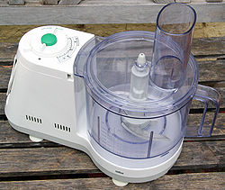

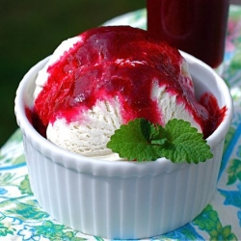

Homework – exam practice

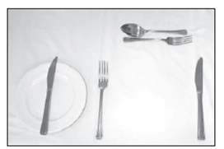
Answer the following questions:
1. Can you name four pieces of small kitchen equipment? (4)
2. (a) Name any three of the items shown. (3)
(b) Give three important items that customers would expect to see on the table (3)
3. The Catering Manager of a Golf Club is interested in purchasing new kitchen equipment. Explain the benefits to the caterer of using the following equipment.
(a) A chilled display cabinet (3)
(b) A dish washer (3)
(c) A food mixer (3)
4. The local supermarket has bought a new hot beverage machine for the café.
(a) Name two beverages available from this type of machine. (2)
(b) Give three benefits to the caterer of having this for the café. (3)

Answers

Mark your answers:
1. Masher, cooks knife, chefs knife, whisk, fish slice (4)
2. (a) Dessert spoon, dessert fork, side plate, butter knife, large/dinner fork, large/dinner knife (3)
(b) Cruet (salt and pepper), other condiments (e.g. sauces), napkins, flower/table decorations, table number, drinking glasses, table cloth, place mats, menus (3)
3. (a) Store food to keep at the correct temperature, customer can see what’s available, customer can serve themselves, food is pre-packed so reduce contamination (3)
(b) Saves time, saves a backlog of dishes, efficient, ensures crockery is cleaned thoroughly, sparkling tableware, sterilized from washing at high temperature (3)
(c) Labour saving, reduces labour cost, time saving, consistent results, variety of uses (e.g. pastry making, cake making, vegetable preparation) (3)
4. (a) Coffee, hot chocolate, tea, soup, hot water (2)
(b) Offers a wide range of products, instant so saves time, hot drinks constantly available, don’t need staff to serve, consistent quality, portion control, saves space, less washing up (3)

