Unit 203 - The Write Up - To use together with your handout

Task: Answer each of the questions below as bullet points:

1.1 Statement of Personal Aims

Q1A - What musical skills and experience do you have, which you can make use of? (6 bullet points)

- x
- x
- x
- x
- x
- x

Q1B - What is your favourite style of music? How does this fit with the music you have composed?

- x
- x

Q1C - What will the people buying the compilation album be expecting?

- x
- x
- x

Q1D - What do you want to achieve with your contribution?

- x
- x
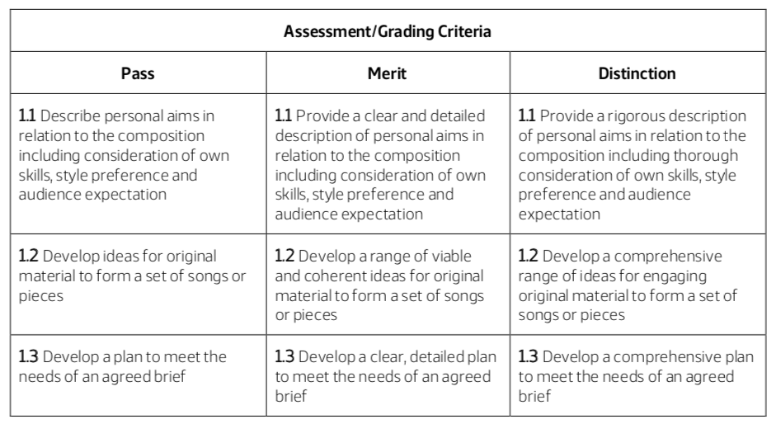
- x
- x
- x

Q1E - How will you know if you have achieved it?

- x
- x
- x
- x
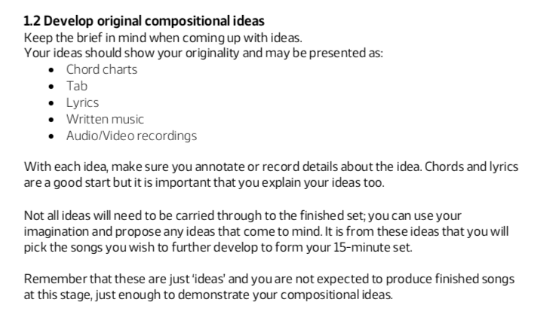
1.2 Develop original compositional ideas. You should:
A: Explain what you are going to do:
- “I plan to make 15 minutes of original music in the form of….” “I would like it to sound like…” “I am really hope I can put across my ideas, which are…”
B: Explain what equipment you are going to use:
- I plan to work on ideas using a keybord/a guitar/writing out lyrics/using an iPad and Garageband/using iMac and Garageband/Using Logic Pro X
C: Most important of all: Write down chord sequences for each section of each song or for all sections of the 1 long song, if that’s how you have done it. REMEMBER: This is the reason you were given the sheets at ths start, where you were actively encouraged to write down the chord sequences.
D: You can use the Score Editor function in Garageband/Logic to show what chord sequences you have used: (PTO)

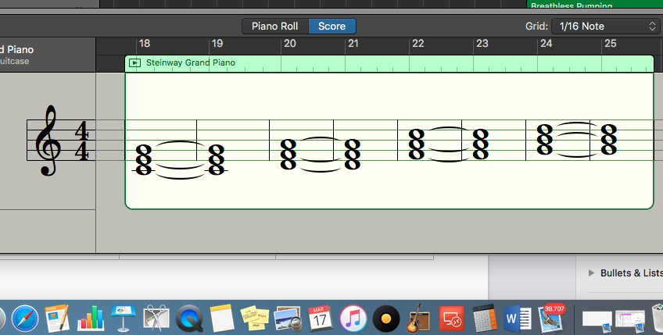

Use the Grab app, to select the Chords for each section, and write something like “These are the chords I plan to use for my first song in the Verse/Bridge/Chorus etc.”

It is really important that you demonstrate ownership of your work.

Final thought: “With each idea, make sure you annotate or record details about the idea. Chords and lyrics are a good start but it is important that you explain your ideas too.”

1.3 A plan of your contribution to the album
You must produce a plan that will help you meet the needs of the brief. The plan should be related to your statement of personal aims and should include details about:
You should: Turn these statements below into questions and answer them, as 1.3 A, B, C, D, E, F, G
- The requirements of the brief and audience and how you will meet them with your compositions (What is the requirement of the brief and how will you meet them with your compositions?)
- What you intend to do within your compositions and how you will do it (What do you intend to do within your compositions and how will you do it?)
- Who do you need to involve?
- What resources you will need e.g. equipment needs?
- The time needed for each activity? (You had 12 hours, so divide that up by the different parts of each piece/section of music to get a approximate answer.)
- The set list of songs that you will take forward from 1.2
- Health and Safety issues where they may apply
  - Safe use of ICT and electrical equipment
  - Regular breaks away from screentime
  - Sensible use of volumess to protect hearing
  - Make sure have water breaks
  - Warm up vocals (if recording vocals) and do not overstretch the voice
  - No food and drink in the studio
  - Make sure leads and cables are taped down and connceted properly (No trip hazards)

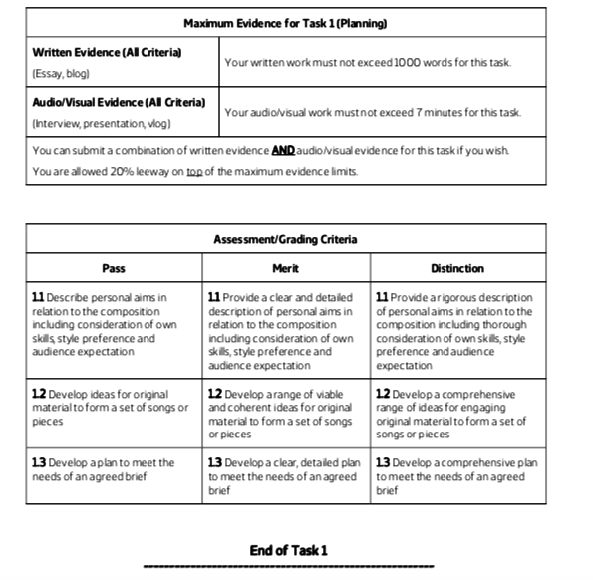

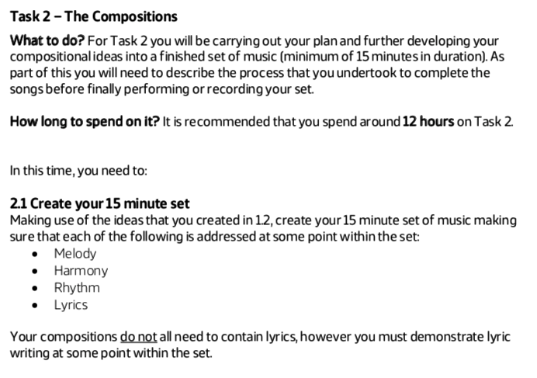

Task 2 - Write see MP3/s labelled:
Task 2.1 - Use the Grab and Score Editor function to show evidence of:
- Melody
- Harmony (chords)
- Rhythm (Chord, melody or bass part rhythm)
- Lyrics

2.2 - Use Grab to show how organised and structured your work is - make sure you have used Arrangement Track and labelled all sections of your music.

2.3 -
Q1: How do the different sections and different pieces work together?

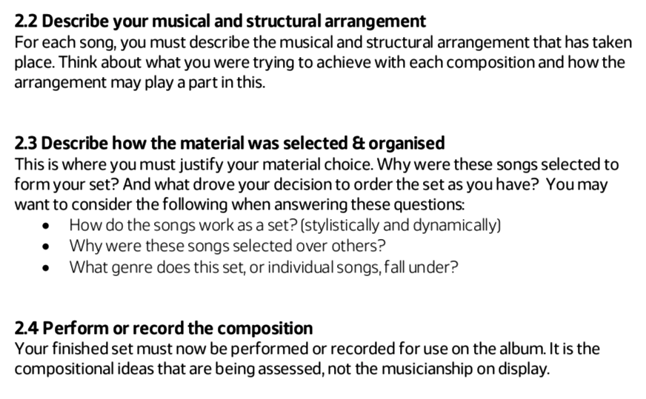
Q2: Why were these songs selected over others - don’t say there were not any others! Write about why you choose to develop these ideas, instead of other ideas, because they…. (You answer)

Q3: What style is your music in; maybe different songs and different sections are in different styles?
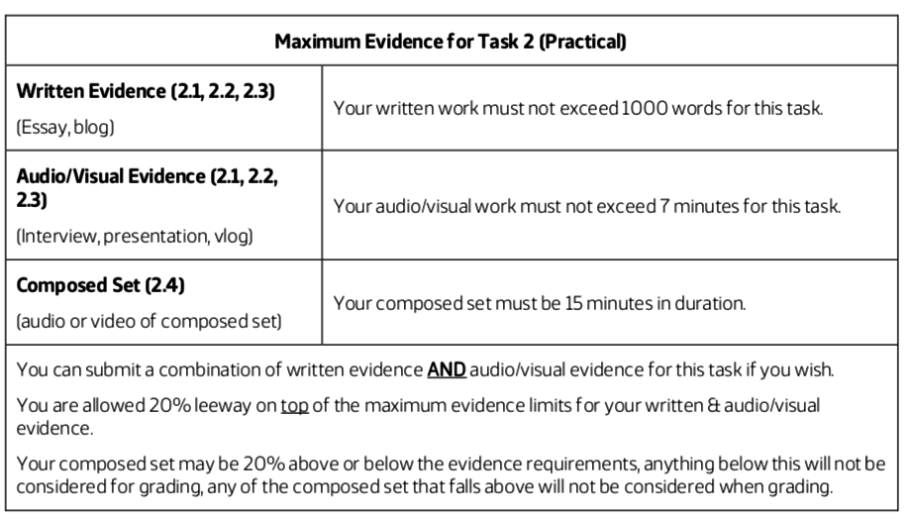
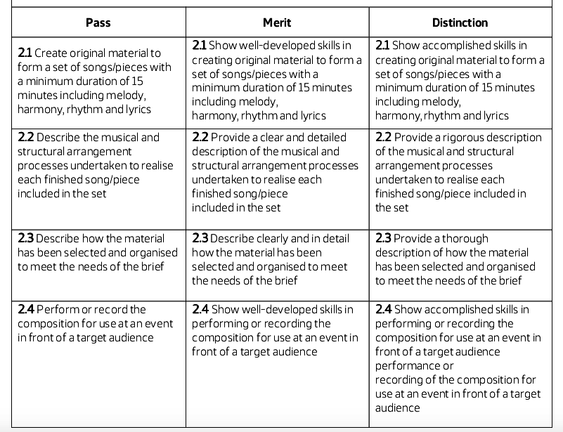

Section 1 & 2 must be completed this week - by Friday 22 March:

I am around:

Monday: Until 4.30
Tuesday: Until 5pm
Wednesday: Until 5pm
Thursday: Until 5pm
Friday: Until 5pm

This has to be your priority - if just 1 assessment point is not answered, you could fail the course.

The deadline is Tuesday night at 5pm - 26 March 2019

